CODE:
DBConnection.java:
import java.sql.Connection;
import java.sql.DriverManager;
public class DBConnection {
public static Connection getConnection() {
Connection con = null;

try {

Class.forName("com.mysql.cj.jdbc.Driver");

String url = "jdbc:mysql://localhost:3306/bankdb";
String username = "root";
String password = "root";

con = DriverManager.getConnection(url, username, password);

System.out.println("Connected to MySQL Successfully!");

} catch (Exception e) {

System.out.println("Connection Failed!");
e.printStackTrace();

}

return con;
}

public static void main(String[] args) {

Connection con = getConnection();

if (con != null) {
System.out.println("Database Connection Established.");
}

}
}
Scenario1.java:
import java.sql.*;

public class Scenario1 {

public static void main(String[] args) {

try {

Connection con = DBConnection.getConnection();

String query =
"UPDATE LOAN SET InterestRate = InterestRate - 1 " +
"WHERE CustomerID IN " +
"(SELECT CustomerID FROM CUSTOMER WHERE Age > 60)";

PreparedStatement ps = con.prepareStatement(query);

int rows = ps.executeUpdate();

System.out.println(rows + " loan records updated.");

con.close();

} catch (Exception e) {

e.printStackTrace();

}

}
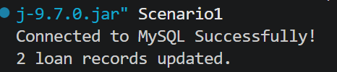

Scenario2.java:
import java.sql.*;

public class Scenario2 {

public static void main(String[] args) {

try {

Connection con = DBConnection.getConnection();

String query = "UPDATE CUSTOMER SET IsVIP = 1 WHERE Balance > 10000";

PreparedStatement ps = con.prepareStatement(query);

int rows = ps.executeUpdate();

System.out.println(rows + " customers promoted to VIP.");

con.close();

} catch (Exception e) {
e.printStackTrace();
}
}
}
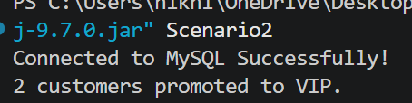
Scenario3.java:
import java.sql.*;

public class Scenario3 {

public static void main(String[] args) {

try {

Connection con = DBConnection.getConnection();

String query =
"SELECT c.Name, l.DueDate " +
"FROM CUSTOMER c JOIN LOAN l " +
"ON c.CustomerID = l.CustomerID " +
"WHERE l.DueDate BETWEEN CURDATE() AND DATE_ADD(CURDATE(), INTERVAL 30 DAY)";

Statement st = con.createStatement();

ResultSet rs = st.executeQuery(query);

while (rs.next()) {

System.out.println(
"Reminder: Dear "
+ rs.getString("Name")
+ ", your loan is due on "
+ rs.getDate("DueDate"));

}

rs.close();
st.close();
con.close();

} catch (Exception e) {

e.printStackTrace();

}

}

}
